Caroline Student
11 Salvador
2011
Equipping an Office
Task 4
Caroline Student
Stuart Design Studio

Table of Contents

Computer System 2
Office Redesigned 2
Infrastructure 2
Security 2
Training 2
References 2
MARKING KEY UNIT 2AAIT 2
Evaluation 2

Computer System
Software
Adobe Creative Suite 5.5 Web Premium provides everything you need to create and deliver standards-based websites with HTML5, jQuery Mobile, and CSS3 support. It contains all the programs this company will need for professional design such as Photoshop Extended and Fireworks. It also has Dreamweaver and will allow this company to design unique websites on a range of platforms. Price US $1799
This company will also be requiring Microsoft Office Professional. Has all the required office tools to create quality products such as brochures and business cards through publisher and also has tools to keep the office organised and efficient such as outlook, excel and word. Price US $499.99
ISP- An internet account with an Internet service provider such as amnet to provide internet service. Shop around for the cheapest deal that suits our office needs. Monthly Payments
Communication Software- Our computers will require Communication Software so the computers can communicate and connect to the internet but this will be provided for free.
Operating System – Good operating system is needed to cope with the processing of designs and allow for smooth work production, minimising lag. Our company will need at least the following on our windows operating system computers.
Windows
- Intel® Pentium® 4 or AMD Athlon® 64 processor
- Microsoft® Windows® XP with Service Pack 3; Windows Vista® Home Premium, Business, Ultimate, or Enterprise with Service Pack 2; or Windows 7
- 1GB of RAM or more recommended
- 9.1GB of available hard-disk space for installation; additional free space required during installation (cannot install on removable flash storage devices)
- 1280x800 display (1280x1024 recommended) with qualified hardware-accelerated OpenGL graphics card, 16-bit colour, and 256MB of VRAM
- Some GPU-accelerated features require graphics support for Shader Model 3.0 and OpenGL 2.0
- Some features in Adobe Bridge rely on a DirectX 9–capable graphics card with at least 64MB of VRAM
- DVD-ROM drive compatible with dual-layer DVDs
- Java™ Runtime Environment 1.6 (included with Adobe)
- Eclipse™ 3.6 required for plug-in installation
- QuickTime 7.6.2 software required for multimedia features
- Adobe® Flash® Player 10 software required to export SWF files
- Broadband Internet connection required for online services and to validate Subscription Edition (if applicable) on an ongoing basis*
Hardware
Computer- Will need a computer the fits the qualifications listed in the software section.
Monitor- Flat screen monitors at least 21 inch for comfort and because this is a design company a good screen in important. Some employees may be more comfortable working with 2 screens to run multiple applcations/programs
Modem- To convert digital signals from the computer to analogue signals that can be transmitted across the telephone line, this company will also have a wireless internet router to provide wireless internet to all office staff.
Telephone Line- Needed to connect to the modem for internet. Our company will be needing multiple lines, fax line, telephone and internet lines. This way calls can be made without stopping the internet and staff working around the office will not have to wait around for shared connection.
Printer/Scanner/Fax Machine- One large communal machine should be enough to cope with this small office. Fax machine can receive incomming corespondence with clients, Laser printer for printing glossy good quality samples that can be shown to clients and a scanner to scan any handrawn designs.

Office Redesigned

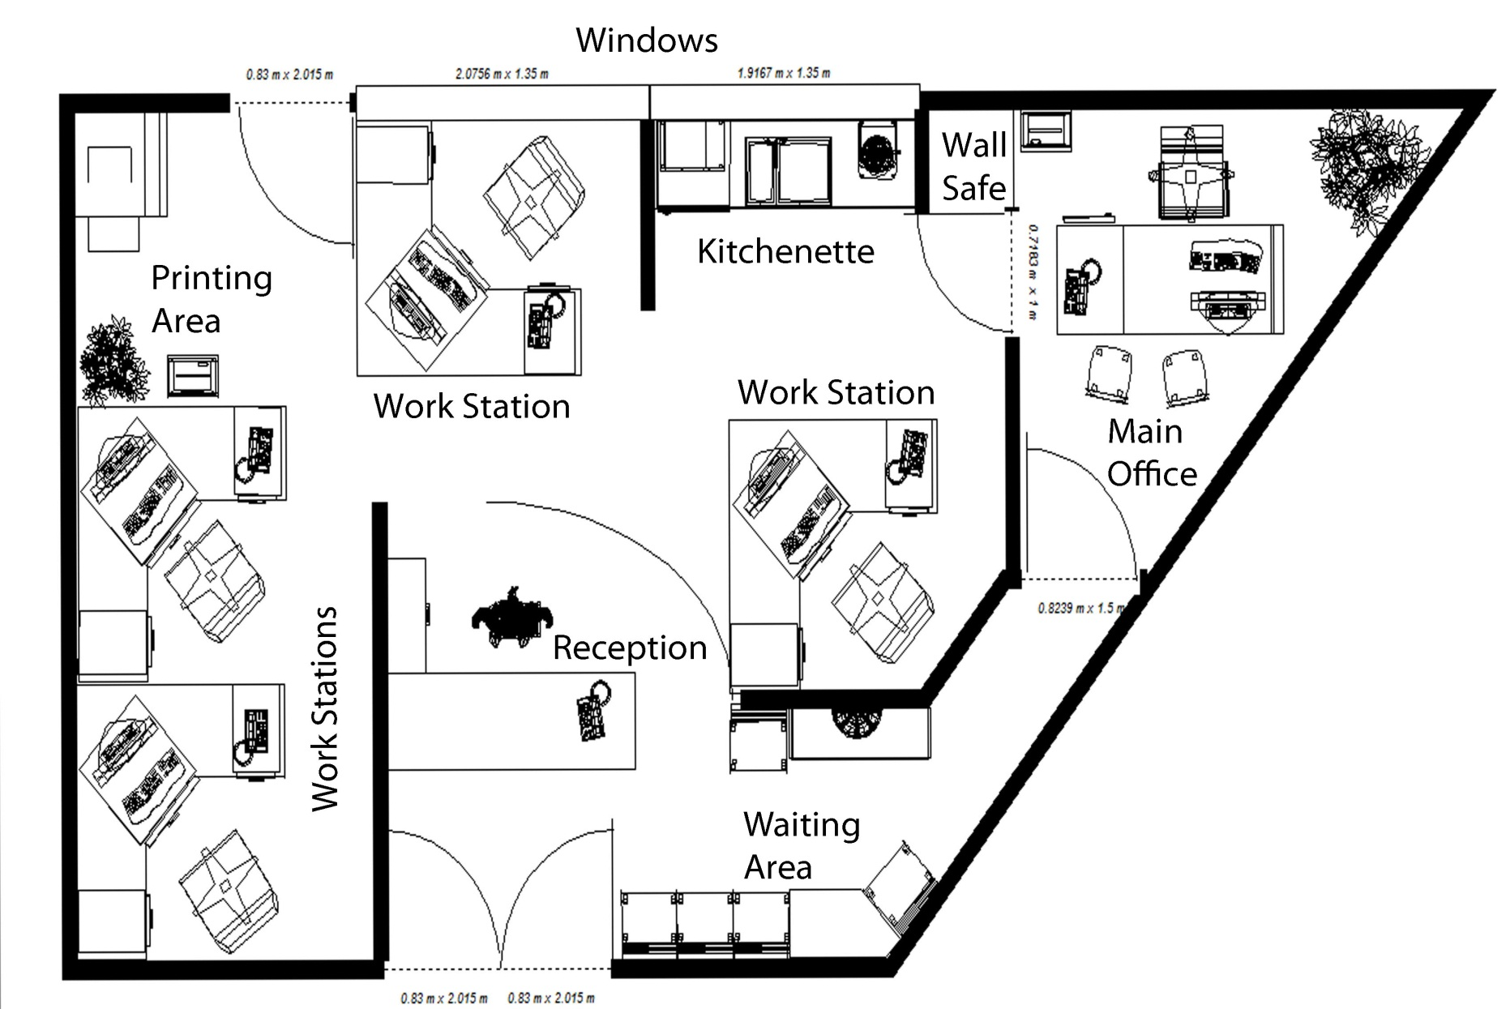

Front and Right Side is Glass (Glass Door).
Adjustable blinds and UV resistant coating on all glass windows and walls.
Back Wall and Left wall are brick (Except Window)
Reverse Cycle Air-conditioned

Infrastructure
In order to provide a comfortable and efficient working environment, ergonomic considerations must be taken into account when designing an office.
Ergonomic Workstations
- Each workstation has “half partition” dividers as well as walls, enclosing 3 sides of each workstation. This allows enough privacy for employees to get work done without the distraction of others. When in a sitting position in front of their computer, employees will not be distracted by other people moving around the office. At the same time I have avoided making individual walled offices as this is a relatively small space and individual offices would be too closed off, they would have stale air and a claustrophobic feeling of being “boxed in.” Therefore this half-way solution is ideal
- Swivel Chairs with adjustable seats for getting the correct height and posture. (Ideal 100-110 degree angle)
- Computer Screen Is directly in front of chairs, as is keyboard which is positioned one arm length away.
- Phone is close-by to avoid overreaching
- All windows have pull down blinds which can be adjusted to remove glare from computer screens. The Windows are UV resistant to protect eyes and skin.
Office Ergonomic Considerations
- The Computer machines have been placed under the desk to save space and keep wires tucked away.
- Power Plug connects to a socket through the desk and into the ground so they are not a tripping hazard.
- Kitchenette contains mini fridge, coffee machine, microwave and sink where employees can take a break. They must also get up for printing/scans/fax/paper shredding. This promotes short breaks from the computer as no matter how comfortable their workstations are breaks are still important. The recommendation is to avoid eye fatigue by resting and refocusing your eyes periodically. Take short 1-2 minute stretch breaks every 20-30 minutes. After each hour of work, take a break or change tasks for at least 5-10 minutes. Always try to get away from your computer during lunch breaks.
- Reverse Cycle Air-conditioning keeps the room a comfortable working temperature and insures the machines do not get damaged.
- Good Lighting
- Office Plants

Networking the computers
All the computers in the office are connected on one network. In this way the office makes use of one network where all information can be shared between employees and information can be sent in from home or remotely.

Communications with clients
Each workstation has a phone and webcam to communicate remotely with clients during a project. Clients can also fax in information through the fax machine or communicate with employees through e-mail. When a client comes in person, they move from the reception to waiting area. Someone from inside can then lead them down the short hall on the right side to the main office. Meetings can take place here between clients, designers and Stuart. This entire area of the office more comfortable and professionally attractive looking and is therefore suitable for client meetings. This is a better option to walking through the cramped, bland and busy main work area and they cannot accidently see employees caught off guard or disturb employees at work.

Security

Antivirus- Any Virus or malicious software that accidently makes its way onto our system through phishing/pharming etc. will be expelled by antivirus. Our office will probably be equipped with Norton antivirus.
Firewall- For online security and to protect data from anything harmful online a firewall is a must.
Encrypted Drive- Worst case scenario, if our computers are infected an encrypted drive would mean the most important data is separate and therefore protected with extra encryption security making it hard to get to.
Back up Drive- To ensure precious work and designs stay safe, information is regularly backed up onto a secure server.
Shatter Proof Windows & Glass
Alarm & Alarm system connected to the Police Department sending out an automatic signal if a break in is detected.
Locks and Security Shutters
Fire Alarm
Disguised Wall Safe- Built into the wall and accessible from the main office for any important documents/money.

Training
Website Developers (Designers)
Our Company will be hiring three additional Website developers/designers to produce black & white leaflets and flyers, Colour leaflets and flyers, Business cards, Colour brochures (A4, 3-panel etc.) and Commercial Web Sites – Designs. Generally we would be looking for a background degree/certificate in graphic designing, fine arts, or publishing indicating their skill with producing attractive designs. They will also need to have taken some computer science courses. However there are many self-made web designers who have learned the required computer skills themselves. It is recommended that a portfolio is present during the interview process. The most crucial requirements are…
- Mastery in computer graphic programs like Photoshop, Dreamweaver, Paint Shop, Adobe Illustrator. (Which are obviously the programs used at this office.)
- Well versed in computer languages like Flash, XHTML, XML based applications and other such development technologies and languages.
- Skilled in using operating systems like Windows, UNIX or Macintosh.
- Good Communication Skills
- Willingness to get the job done despite erratic schedules and sometimes strict deadlines.
Other than academic qualifications and computer competency our employees need good verbal and visual skills to work with clients. If ideas are poorly presented clients may choose to take their business elsewhere where they believe a better job will be done or where they will be listened to. It is important to be open to various ideas and suggestions.
There will be pressures of meeting constantly changing demands and strict deadlines. It is a demanding profession. Hence, it is important that employees are motivated.
The annual web designer salary ranges from $51,750 to $74,520 according to the Bureau of Labour Statistics. The amount employees makes depends on the quality & quantity of their individual work or position at the company e.g. Web design directors many earn more.
Computer Technician
In a company so heavily dependent on technology a good computer technician is crucial to keeping the business running smoothly. Computer technicians should possess a great deal of knowledge about the different internal parts of a computer's hardware and how to repair them. Their general duty is to install new programs or parts into computers, to perform regular computer maintenance and to solve people's computer issues. When hiring a computer technician they should already have a college degree or certification. It would be preferable if they had work experience and need to be good problem solvers, able to work under pressure and come up with solutions so other employees can return to work as quickly as possible.
For this office it would be useful if our computer technician specialized or was well versed in dealing with windows computers and the relevant design packages used at the company.
Bureau of Labour Statistics reports that computer support technicians earn an average of $39,100 per year.

References

http://www.adobe.com/products/creativesuite/web/tech-specs.html
http://office.microsoft.com/en-us/buy/office-2010-which-suite-is-right-for-you-FX101825640.aspx
http://www.adobe.com/products/creativesuite/web/buying-guide.html
http://www.webdesignersalarydata.com/how-to-become-web-designer.html
http://www.ehow.com/about_5537929_computer-technician-qualifications.html
http://www.ergonomics.com.au/

MARKING KEY UNIT 2AAIT

Student Name: Caroline The

Task 4: Equipping an office Total: 100 marks

Items | Possible  mark | Actual  mark
Section 1 Computer system | 30
Hardware specifications | 20
Software & Prices | 10
Section 2 Infrastructure | 30
Re- Design of Office - Workstations etc. | 10
Network configurations Staff and Client communication | 10
Ergonomic Considerations | 10
Section 3 Security | 10
Physical security & Malicious software | 5
Data security | 5
Section 4 Training | 10
Job description of both | 5
Training of both | 5
Section 4 Formatted report | 20
Referencing of all sources used | 5
Report is correctly formatted | 5
Cover page Table of contents | 5
Headers/footers Graphics | 5
Total | 100

Teacher comment:

Evaluation

Evaluation Individual Task 4

Task 4 Number

Your Name Caroline The Date 7/7/2011

You have been working on a task. Part of your task is to honestly evaluate your own performance. This evaluation will assist in the determination of some of the course outcomes. It is a confidential evaluation and only Mr Faulks will read it.
List down all the aspects that you have completed during the task
i.e. Investigating, Devising, Producing etc.
I investigated Ergonomics, Software and Hardware for a Design Office. I also looked into Job prospects for computer technicians and graphic designers. I learned how to use the architecture program and designed and office then filled in this report

List down any of the new skills you have learnt while undertaking this task.
I learned how to use the 3D program to design an architectural design.

What are some things you have found out about yourself while investigation this task (e.g. – I didn’t know I had such good leadership qualities, I always need someone to keep me on task)
Nothing I didn’t already know

Reflect on the process that you have gone through since commencing your investigation of this task, write about any successes or problems you have personally encountered.

All the information was pretty easy to find since I knew what I was looking for but the actual amount of possibilities for this task was huge.

Do you consider yourself to be a consistent worker (eg will be on task for most of the week). Why? Why Not? Give examples where appropriate.
Well I probably did more work than the people around me and divided my time to work, I got everything done on time but I should probably focus more so I finish faster

Do you think your application to the task has improved your planning skills? Why? Why Not? Give examples where appropriate
Not really, I was planning/not planning the same as I usually do to get stuff done

Rate yourself 0 to 10 on the following criteria (10 being excellent)
Ability to locate information & research without any assistance | 10
Shows initiative | 10
Leadership Qualities | 0.o  Lead What?
Application to the task | 5
Time Management | 4
Works without any ‘nagging’ from the teacher | 7
Did you personally enjoy investigation of this task
Yes / No Why: I generally dislike researching things and the hardware stuff confused me since I don’t have much of a background in computers.

What are some things you liked about this task?
The graphic designer job prospect thing was pretty interesting though because it sort of relates to me. Also discovering the 3D design program because it was like playing the Sims and because I’m quite into design and being creative like that.

What are some things you disliked about this task?
Researching the hardware and typing up things that were pretty simple or self-explanatory. I’m not a particularly focused/fast typer either

The course requires you to think a lot for yourself and to find out your own information, did you find this type of environment an enjoyable one to work in, or do you prefer the teacher up the front of the class teaching the information and then getting tested on it?
Please comment.
I do prefer this over just being taught the information because I can manage my own time and have a fun class. However, it would be good if the new/essential course stuff was taught to us because then I might actually learn and remember it for an exam. Tutorials on the more complex features of adobe programs might also be interesting.

